Cvbcvbncvbn cn

Cvbnxcv

N

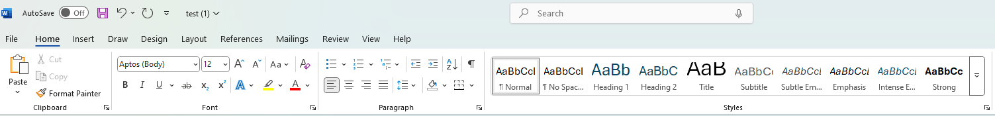

Xcvbn

Xcb

Ncb

Nxc

Vn

xcvn